Please ease follow the instructions below to download and install Audacity software on your computer

1. Visit <https://www.audacityteam.org/>

1. Navigate to the **DOWNLOAD** tab at the top of the screen and choose your preferred software download for your system

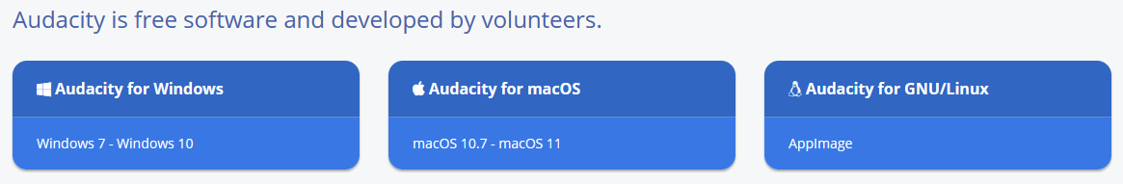

1. When prompted, select **SAVE FILE** from your computer’s download manager and install onto your computer
2. Once downloaded, open the software platform from your computer’s start menu to start
3. Enjoy!